GRAPHICAL SOLUTION OF EQUATIONS USING AUTOGRAPH

We can use graphs to find approximate solutions of a wide range of equations, which it may not be possible to solve by other methods:

Example:
Draw the graph y = 2x² - x - 3. Use the graph to find solutions to these equations:
a) 2x² - x - 3 = 6 b) 2x² - x = x + 5.

Solution:
- To solve 2x² - x - 3 = 6, the line y = 6 is also drawn. At the points of intersection (A and B), y equals both (2x² - x - 3) and 6, so 2x² - x - 3 = 6. The solutions are therefore the x co-ordinates at these two points
i.e. x = - 1.9 and x = 2.4 approx.
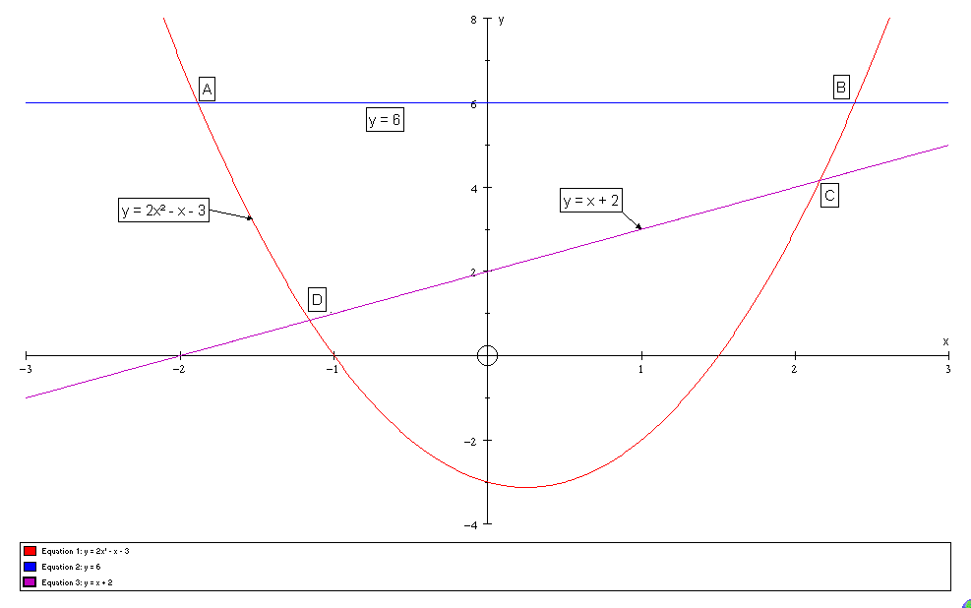

- To solve 2x² - x = x + 5, first re-arrange the equation to obtain 2x² - x - 3 on
the left-hand side: 2x² - x = x + 5
2x² - x - 3 = x + 2

This tells us we need the intersection of the lines y = 2x² - x - 3 and y = x + 2.
These intersect at the points C and D, giving solutions x = - 1.2 and x = 2.2
approx.

Questions

- By drawing the graph of y = x² - 2x + 2 and other graphs, solve the equations:
a) x² - 2x + 2 = 8 b) x² - 2x + 2 = 5 - x c) x² - 2x - 5 = 0.

- Draw the graph y = x² - 7x. Draw suitable straight line graphs to solve the equations:
a) x² - 7x + 9 = 0 b) x² - 5x + 1 = 0.

- Draw the graph y = 2x² + 3x - 9. Draw suitable straight line graphs to find approximate solutions of the equations:
a) 2x² + 3x - 4 = 0 b) 2x² + 2x - 9 = 1.

- Draw the graph y = 18/x. Use the graph to find approx solutions to the equations:
a) 18/x = x + 2 b) 18/x + x = 10 c) x² = 18

- Draw the graph of y = 0.5x² - 6.
- Use the graph to find approximate solutions to the equation 0.5x² - 6 = 1.
- By re-arranging the equation in a), explain why these values are approximately ±√14.
- Use your graph to find approximate values for the square roots of 8.

